CPE301 – SPRING 2019

Design Assignment 2C

Student Name: John Duriman

Student #: 5002373995

Student Email: duriman@unlv.nevada.edu

Primary Github address: https://github.com/johnduriman/pirahnaplant.git

Directory: pirahnaplant/Design Assignments/DA2C/

1. **COMPONENTS LIST AND CONNECTION BLOCK DIAGRAM w/ PINS**

Only the Atmega328P was used for this assignment including the following ports:

PORTB.2 is used as an output—connected to an LED

PORTC.1 is used as an input—connected to the button

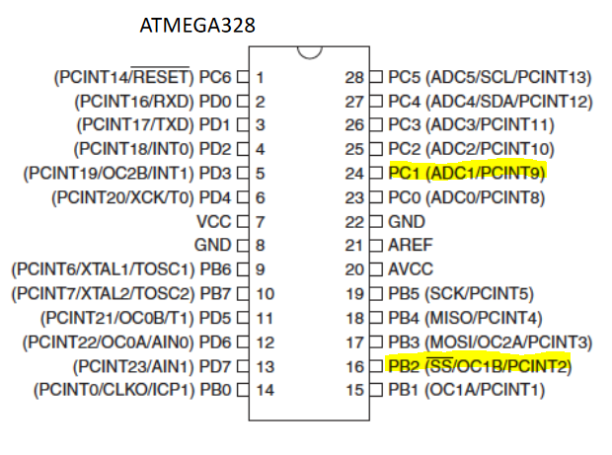

1. 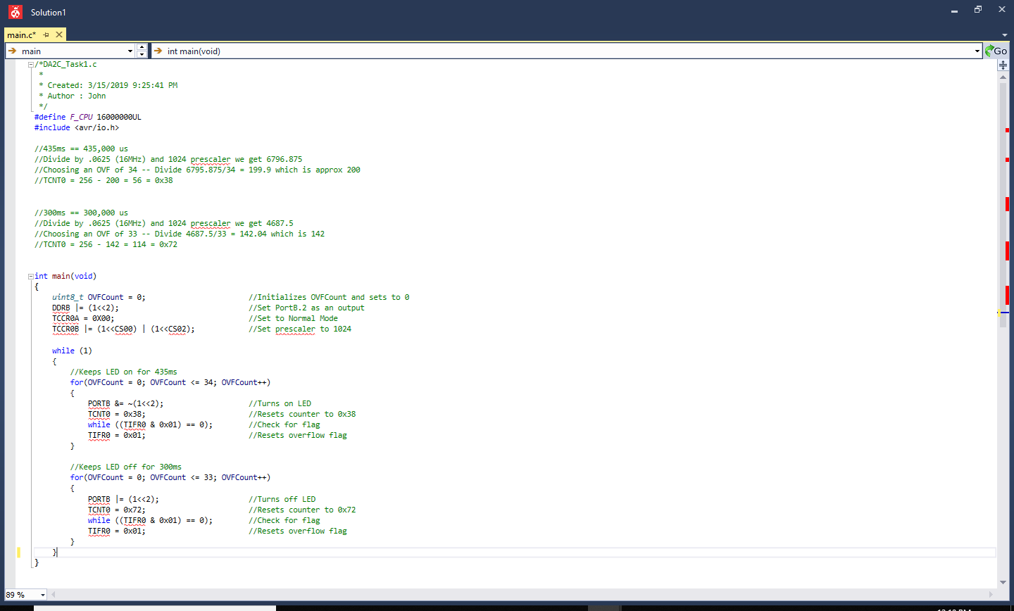**CODE OF TASK 1A**
2. 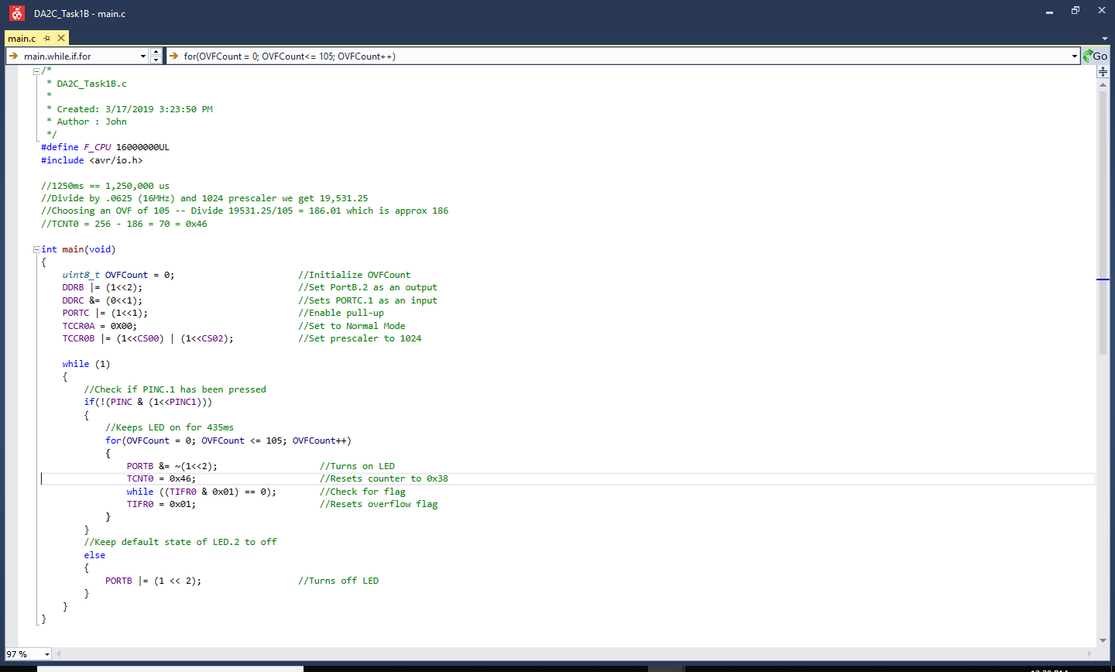**CODE OF TASK 1B**
3. **CODE OF TASK 2A**

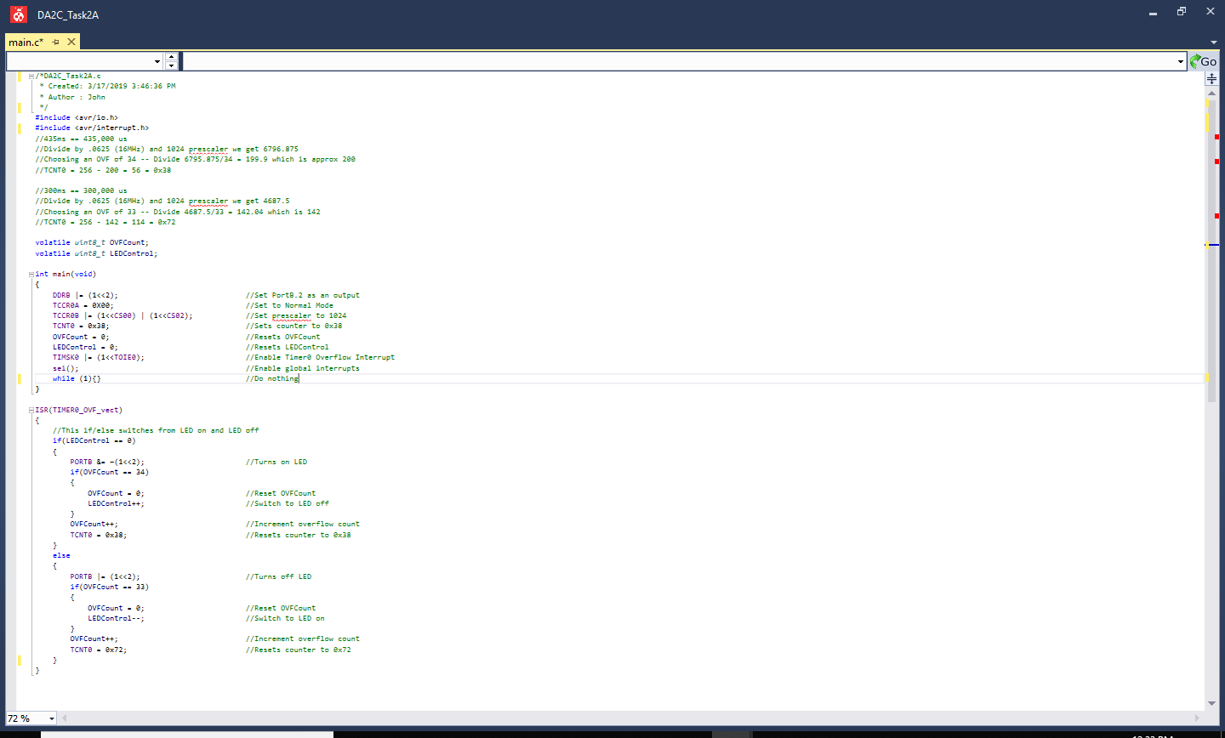

1. 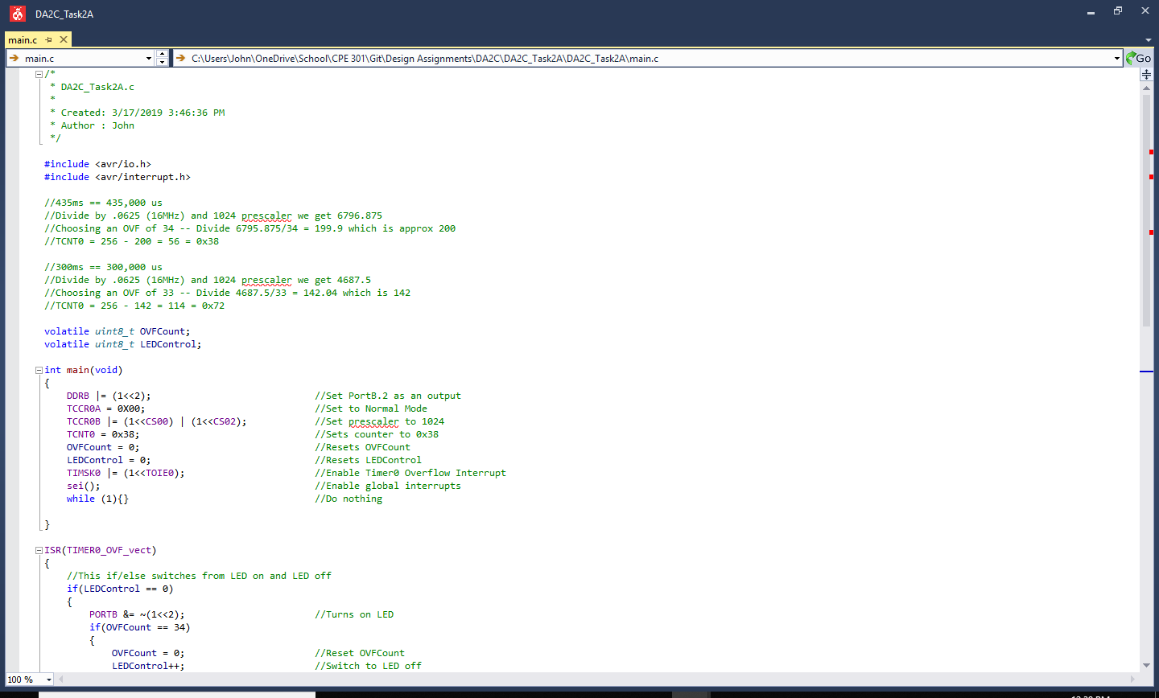**CODE OF TASK 2B**

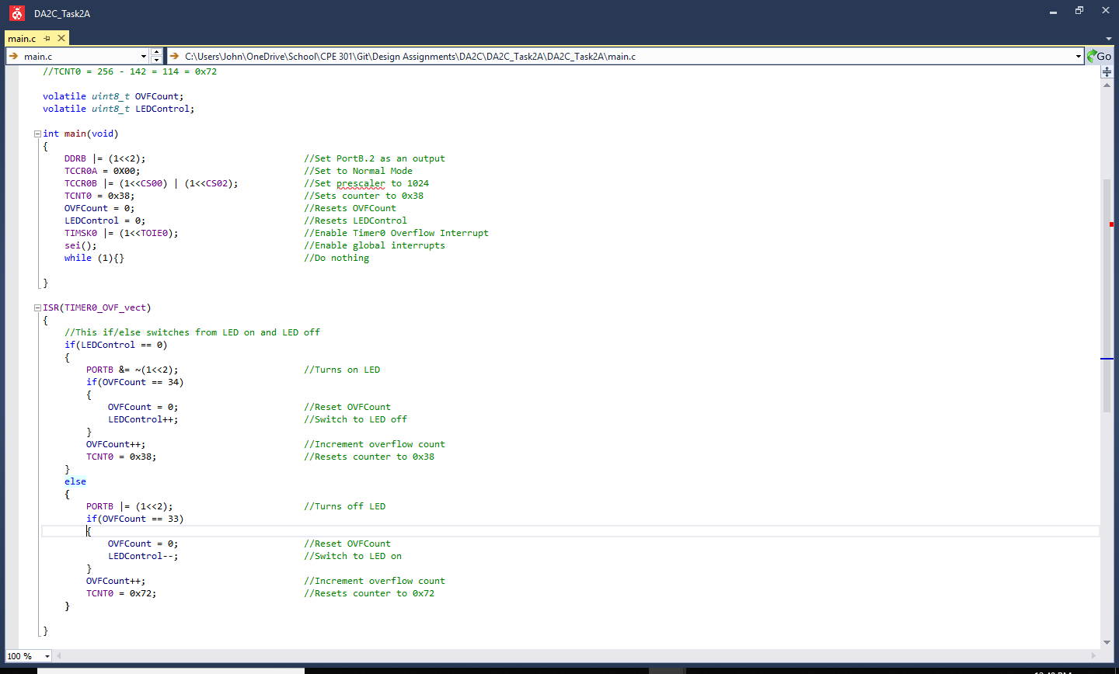

1. 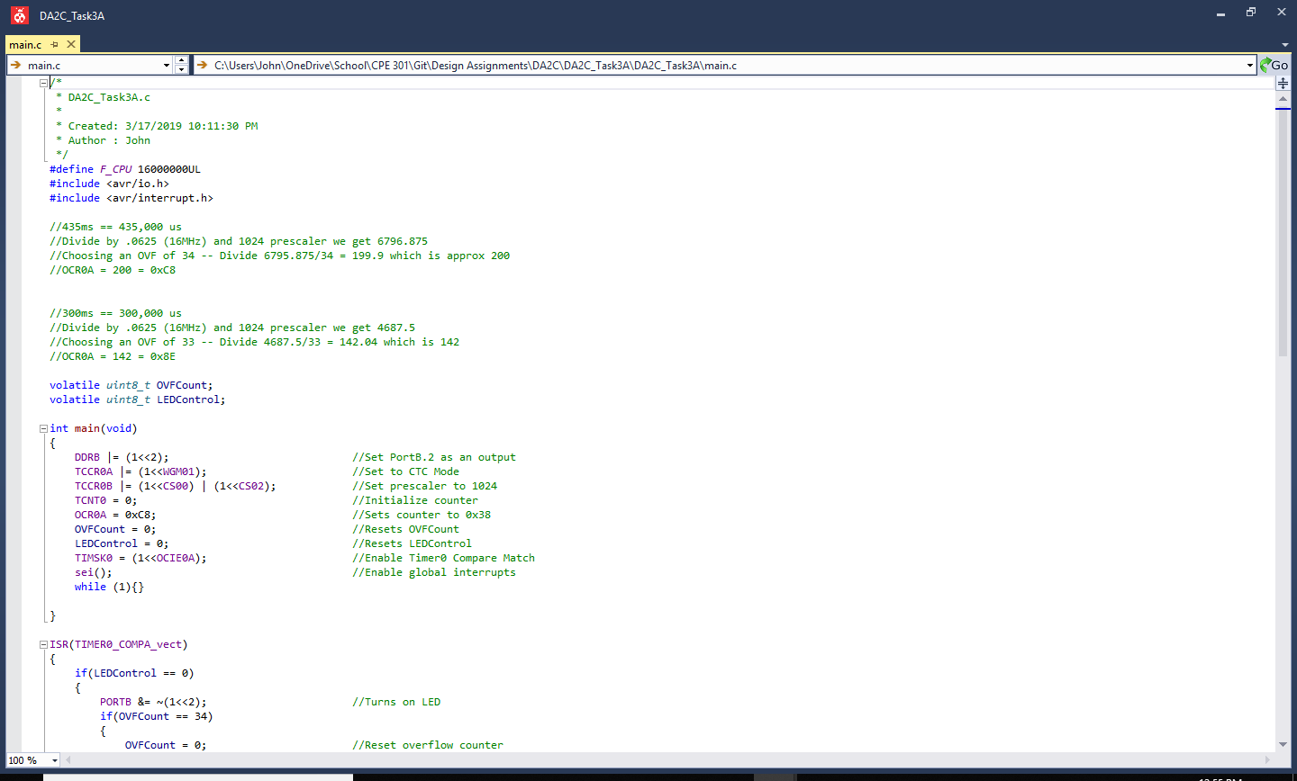**CODE OF TASK 3A**

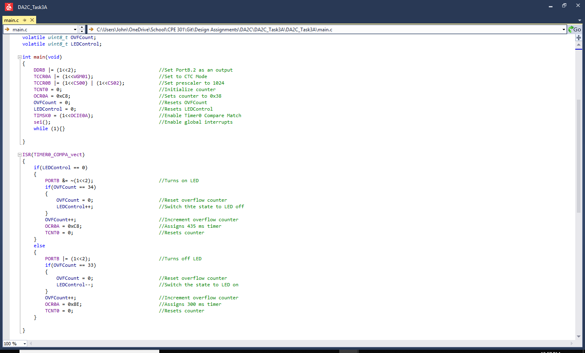

1. **CODE OF TASK 3B**

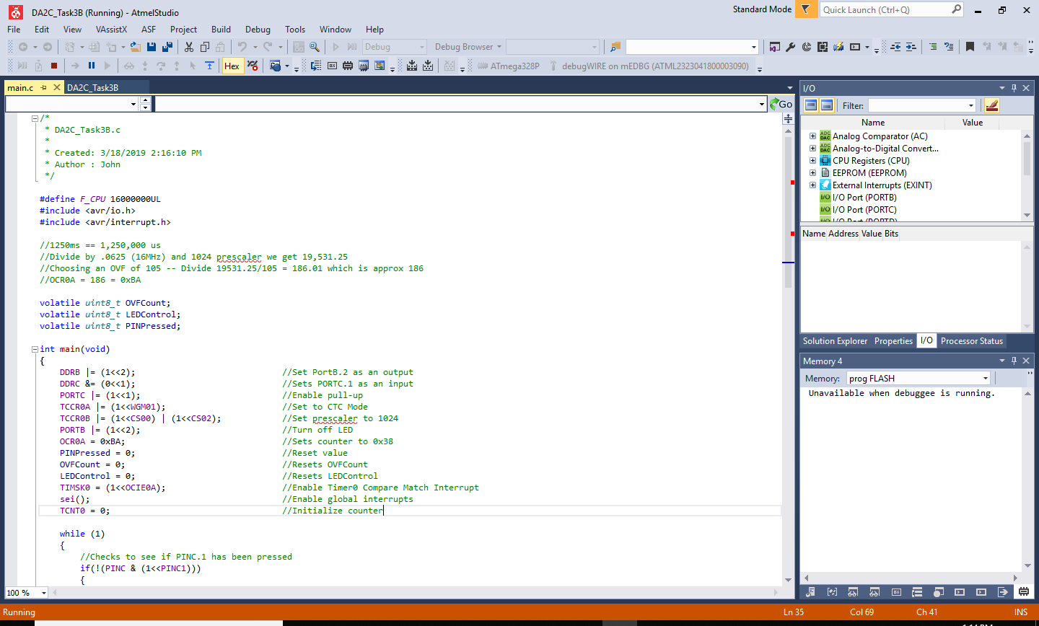

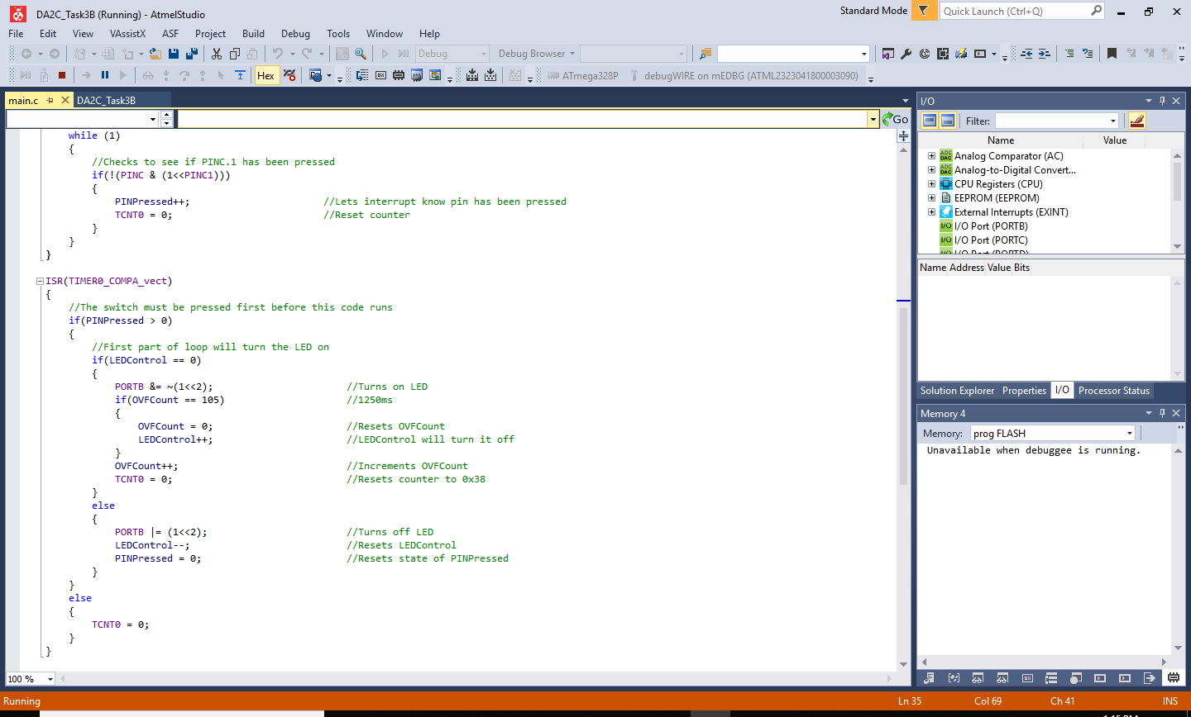

1. **SCHEMATICS**

Use fritzing.org

1. **SCREENSHOTS OF EACH TASK OUTPUT (ATMEL STUDIO OUTPUT)**
2. **SCREENSHOT OF EACH DEMO (BOARD SETUP)**
3. **VIDEO LINKS OF EACH DEMO**

https://youtu.be/FSf4rl-55Bo

1. **GITHUB LINK OF THIS DA**

https://github.com/johnduriman/pirahnaplant.git

**Student Academic Misconduct Policy**

<http://studentconduct.unlv.edu/misconduct/policy.html>

“This assignment submission is my own, original work”.

John Duriman